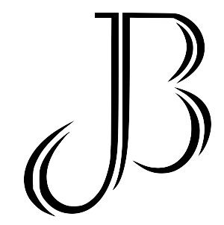

L

Tracking Worksheet
Physical Conditioning

Demographic Information
Name
Age
Sport
Goal
TDEE
Test | Height | Weight | Reach | Body Fat %
Evaluation
Progress #1
Mid-Term
Progress #2
Final

My Calisthenics Maxes
Test | Pull-Ups | Squat | Sit-Ups | Push-Ups | Lunges | Dips
Evaluation
Progress #1
Mid-Term
Progress #2
Final

My 1 Rep Maxes
Test | Bench Press | Squat | Deadlift | 400m | Mile | PACER/5k
Evaluation
Progress #1
Mid-Term
Progress #2
Final

Numbers to Know
1 lap around the track = 400 meters
4 laps around the track = 1 mile
12.5 laps around the track = 5k
20 laps around a HS basketball court = 1 mile
19 laps around a NCAA basketball court = 1 mile
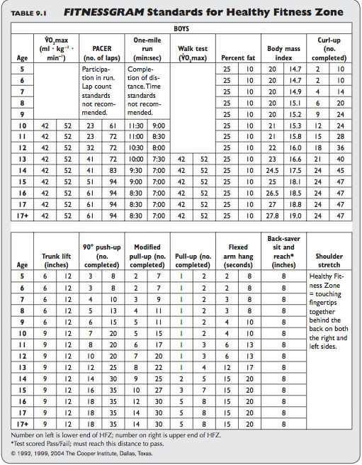

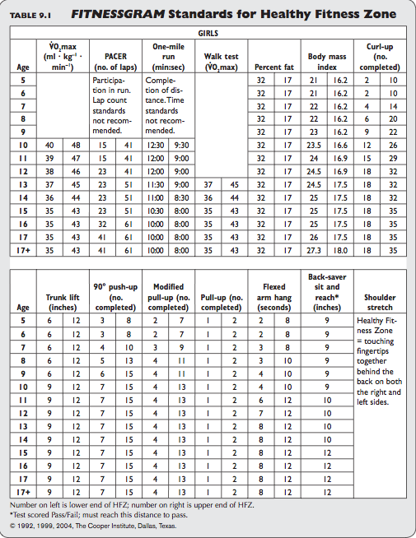

Male Strength Standards Ages 14-17
Bench Press
Bodyweight | Beginner | Novice | Intermediate | Advanced | Elite
120 | 57 | 86 | 124 | 167 | 215
130 | 65 | 97 | 136 | 181 | 231
140 | 74 | 107 | 147 | 195 | 246
150 | 82 | 117 | 159 | 208 | 261
160 | 90 | 126 | 171 | 221 | 276
170 | 98 | 136 | 181 | 233 | 290
180 | 106 | 144 | 191 | 245 | 303
190 | 114 | 154 | 202 | 257 | 316
200 | 121 | 163 | 212 | 268 | 328
210 | 129 | 171 | 222 | 279 | 340
220 | 136 | 179 | 231 | 290 | 352
230 | 143 | 187 | 241 | 300 | 364
240 | 150 | 196 | 250 | 311 | 374
250 | 157 | 204 | 258 | 320 | 385
260 | 164 | 211 | 267 | 330 | 396
270 | 171 | 218 | 276 | 339 | 406
280 | 177 | 226 | 284 | 348 | 416
290 | 183 | 233 | 292 | 358 | 426
300 | 190 | 240 | 300 | 366 | 435
310 | 196 | 247 | 307 | 375 | 445

Female Strength Standards Ages 14-17
Bench Press
Bodyweight | Beginner | Novice | Intermediate | Advanced | Elite
100 | 20 | 40 | 69 | 105 | 147
110 | 23 | 44 | 75 | 112 | 156
120 | 26 | 49 | 81 | 119 | 164
130 | 30 | 53 | 86 | 126 | 172
140 | 33 | 57 | 91 | 133 | 179
150 | 36 | 62 | 97 | 139 | 186
160 | 39 | 65 | 101 | 144 | 193
170 | 42 | 70 | 106 | 151 | 200
180 | 44 | 73 | 111 | 156 | 206
190 | 47 | 77 | 115 | 161 | 212
200 | 50 | 80 | 119 | 166 | 218
210 | 53 | 84 | 124 | 171 | 224
220 | 56 | 87 | 127 | 176 | 229
230 | 57 | 90 | 131 | 180 | 234
240 | 60 | 93 | 135 | 184 | 238
250 | 63 | 96 | 138 | 189 | 244
260 | 65 | 99 | 142 | 192 | 248

Male Strength Standards Ages 14-17
Squat
Bodyweight | Beginner | Novice | Intermediate | Advanced | Elite
120 | 87 | 131 | 186 | 252 | 323
130 | 100 | 146 | 205 | 273 | 347
140 | 112 | 161 | 222 | 293 | 370
150 | 125 | 176 | 240 | 313 | 392
160 | 137 | 190 | 256 | 332 | 413
170 | 149 | 204 | 272 | 350 | 434
180 | 160 | 218 | 288 | 368 | 453
190 | 172 | 231 | 303 | 385 | 473
200 | 183 | 244 | 318 | 402 | 491
210 | 194 | 257 | 333 | 418 | 509
220 | 205 | 269 | 347 | 434 | 526
230 | 215 | 281 | 360 | 449 | 543
240 | 225 | 293 | 374 | 464 | 560
250 | 236 | 305 | 387 | 479 | 576
260 | 246 | 316 | 400 | 493 | 591
270 | 255 | 327 | 412 | 507 | 606
280 | 265 | 338 | 424 | 520 | 621
290 | 274 | 349 | 436 | 534 | 635
300 | 284 | 359 | 448 | 546 | 650
310 | 293 | 370 | 459 | 559 | 663

Female Strength Standards Ages 14-17
Squat
Bodyweight | Beginner | Novice | Intermediate | Advanced | Elite
100 | 43 | 76 | 121 | 177 | 239
110 | 48 | 83 | 130 | 187 | 252
120 | 53 | 90 | 138 | 197 | 263
130 | 58 | 96 | 146 | 207 | 274
140 | 63 | 103 | 154 | 216 | 284
150 | 68 | 108 | 161 | 224 | 294
160 | 72 | 114 | 168 | 232 | 303
170 | 77 | 119 | 174 | 240 | 312
180 | 81 | 125 | 181 | 247 | 320
190 | 85 | 130 | 187 | 254 | 328
200 | 89 | 134 | 193 | 261 | 336
210 | 93 | 139 | 198 | 268 | 343
220 | 96 | 144 | 204 | 274 | 351
230 | 100 | 148 | 209 | 280 | 357
240 | 103 | 152 | 214 | 286 | 364
250 | 107 | 157 | 219 | 292 | 371
260 | 110 | 161 | 224 | 297 | 377

Male Strength Standards Ages 14-17
Dead Lift
Bodyweight | Beginner | Novice | Intermediate | Advanced | Elite
120 | 99 | 143 | 198 | 260 | 329
130 | 111 | 158 | 215 | 280 | 351
140 | 124 | 172 | 231 | 299 | 372
150 | 135 | 185 | 247 | 318 | 392
160 | 158 | 212 | 278 | 352 | 430
170 | 169 | 225 | 292 | 368 | 448
180 | 179 | 237 | 305 | 384 | 466
190 | 179 | 237 | 305 | 384 | 466
200 | 190 | 249 | 319 | 399 | 482
210 | 200 | 261 | 332 | 413 | 499
220 | 210 | 272 | 345 | 427 | 514
230 | 220 | 283 | 358 | 441 | 529
240 | 230 | 294 | 370 | 455 | 544
250 | 238 | 305 | 382 | 468 | 559
260 | 248 | 315 | 393 | 480 | 573
270 | 257 | 325 | 416 | 506 | 599
280 | 265 | 335 | 416 | 506 | 612
290 | 274 | 345 | 426 | 517 | 612
300 | 283 | 354 | 437 | 529 | 625
310 | 292 | 363 | 447 | 540 | 637

Female Strength Standards Ages 14-17
Dead Lift
Bodyweight | Beginner | Novice | Intermediate | Advanced | Elite
100 | 50 | 84 | 127 | 180 | 238
110 | 56 | 90 | 136 | 190 | 250
120 | 61 | 97 | 144 | 199 | 261
130 | 66 | 104 | 151 | 208 | 271
140 | 70 | 110 | 158 | 217 | 281
150 | 76 | 115 | 165 | 225 | 290
160 | 80 | 120 | 171 | 232 | 298
170 | 84 | 125 | 178 | 239 | 306
180 | 89 | 131 | 184 | 246 | 314
190 | 92 | 136 | 190 | 253 | 322
200 | 97 | 140 | 196 | 259 | 329
210 | 100 | 145 | 201 | 265 | 336
220 | 104 | 150 | 206 | 271 | 343
230 | 107 | 153 | 211 | 278 | 349
240 | 111 | 158 | 216 | 283 | 356
250 | 114 | 162 | 220 | 288 | 361
260 | 117 | 165 | 225 | 293 | 367

